Documentation SMACT-Dashboard

To begin with, I started the Power BI programme and created a new file. Then I clicked on the field "SQL-Server" and connected to the SQL-Server of the SMACT project.

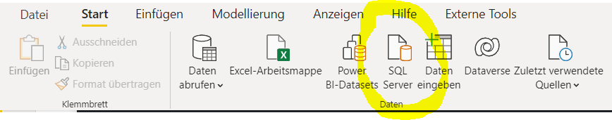

Then I connected to the SQL server with the names, the usernames, and the password. For the data connectivity mode, I choose Direct Query so that I can fetch live data.

Ein Bild, das Text enthält.
Ein Bild, das Text enthält.

Then I took the data I needed from the database and inserted them. The Data I used is in these Tables:

* [CRONUS Smact$Warehouse Entry$437dbf0e-84ff-417a-965d-ed2bb9650972]
* [CRONUS Smact$Production Order$437dbf0e-84ff-417a-965d-ed2bb9650972]
* [CRONUS Smact$EOSFH Report Task$59df57a5-0fc9-45d9-858a-950a1e229031]

After importing, the first thing I did was the "General" page. This consists of 2 bar charts and 2 line charts and the page navigator.

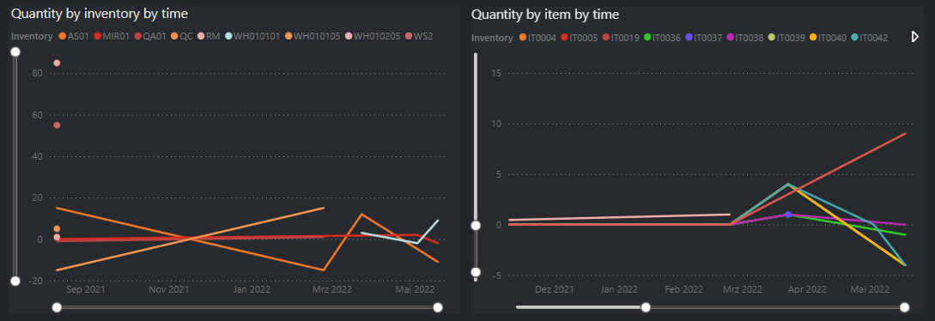

On the line charts I have shown the number of parts in the warehouse by time and the number of individual parts by time. The x-axis shows the "Registering Date", the y-axis the "Quantity" and the legend the "Bin Code" for the warehouse and the "Item No_" for the products. To get this data I used the following queries:

* select [Registering Date], [Bin Code], Quantity from [CRONUS Smact$Warehouse Entry$437dbf0e-84ff-417a-965d-ed2bb9650972] order by [Registering Date], [Bin Code]
* select [Registering Date], [Item No_], Quantity from [CRONUS Smact$Warehouse Entry$437dbf0e-84ff-417a-965d-ed2bb9650972] order by [Registering Date], [Item No_]

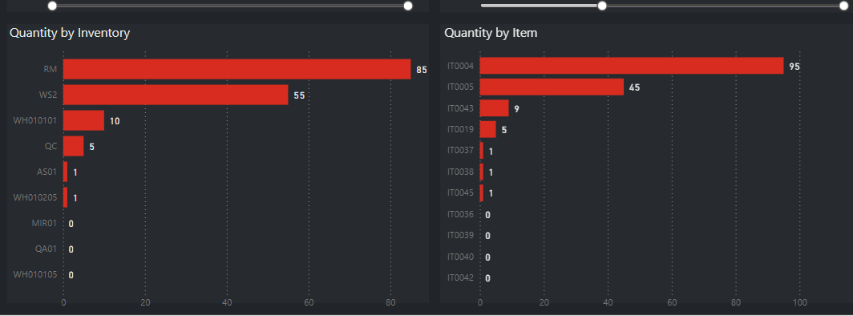

On the bar charts I show the sum of all products per warehouse and the sum of all products per se. The X-axis shows the "Quantity" and the Y-axis the "Bin Code" for the warehouses and the "Item No_" for the products.

To get this data I used the following queries:

* select [Bin Code], sum(Quantity) from [CRONUS Smact$Warehouse Entry$437dbf0e-84ff-417a-965d-ed2bb9650972] group by [Bin Code] order by [Bin Code]
* select [Item No_], sum(Quantity) from [CRONUS Smact$Warehouse Entry$437dbf0e-84ff-417a-965d-ed2bb9650972] group by [Bin Code] order by [Item No_]

On the second and third page I have made a diagram for the number of products in the warehouses and the number of products themselves for each warehouse and for each product individually.

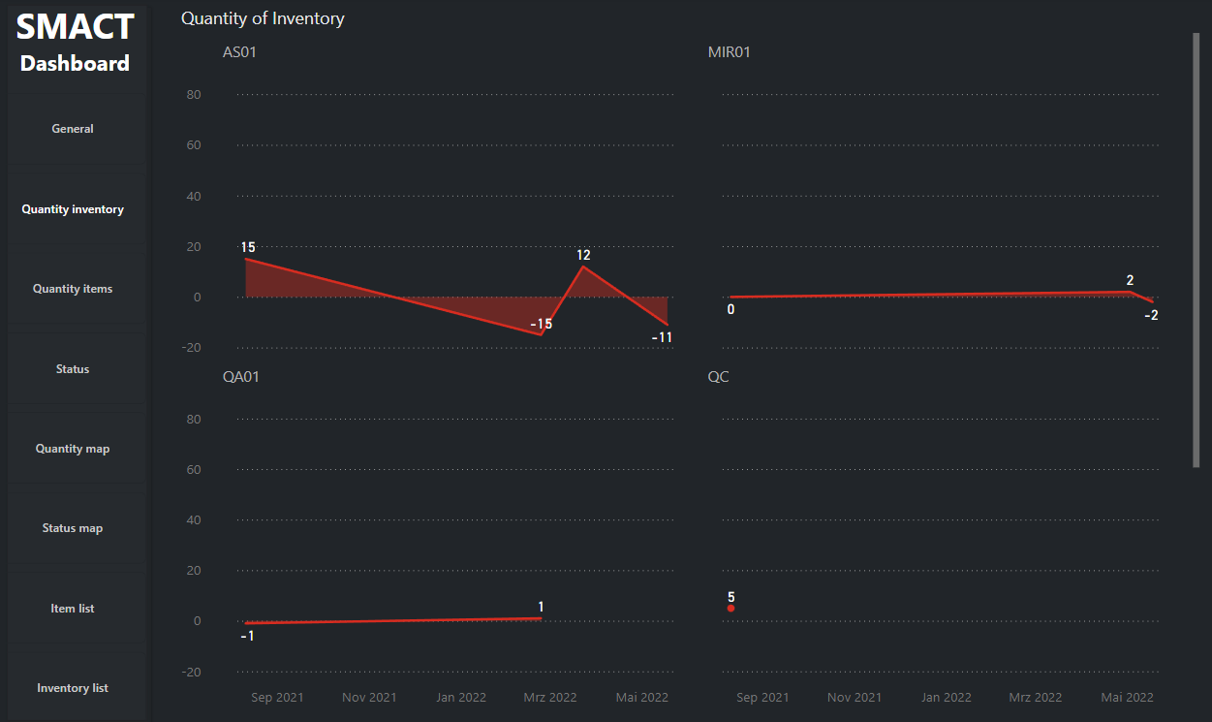

On the second page, it shows each warehouse and its number of products. For this I have taken the "Registering Date" as the X-axis and the "Quantity" as the Y-axis. As "Small Multiples" I have then taken "Bin Code" so that it displays all the warehouses individually. I took the line chart as the graph. To get this data I used the following queries:

* select [Registering Date], [Bin Code], Quantity from [CRONUS Smact$Warehouse Entry$437dbf0e-84ff-417a-965d-ed2bb9650972] order by [Registering Date], [Bin Code]

Ein Bild, das Text enthält.

On the third page, it shows each product and its quantity. For this I have taken the "Registering Date" as the X-axis and the "Quantity" as the Y-axis. I then took "Item No_" as the "Small Multiples" so that it displays all products individually. I took the line chart as the graph. To get this data I used the following queries:

* select [Registering Date], [Item No_], Quantity from [CRONUS Smact$Warehouse Entry$437dbf0e-84ff-417a-965d-ed2bb9650972] order by [Registering Date], [Item No_]

On the third page I used two bar charts to show the number per status and the status per task.

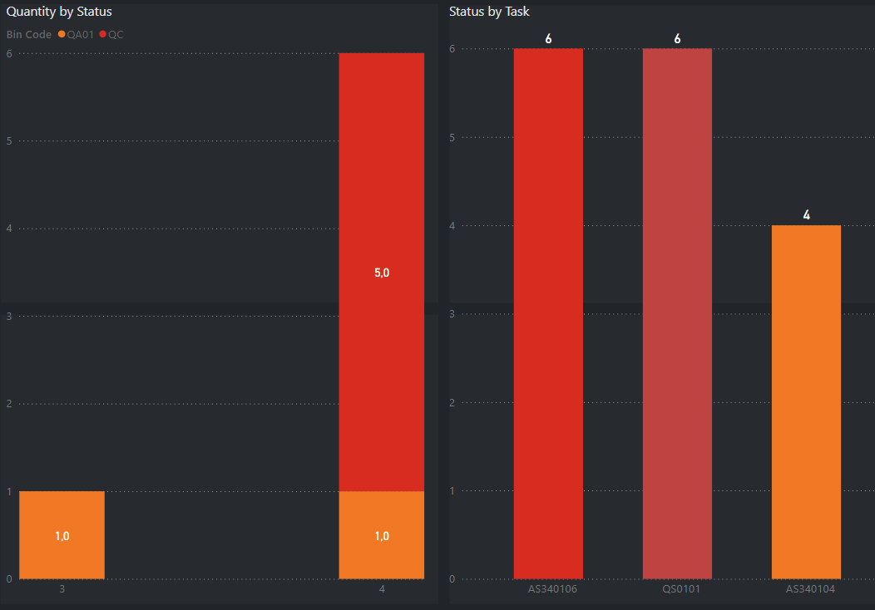

On the left bar chart, I have used "Status" as the X-axis, "Quantity" as the Y-axis and "Bin Code" as the legend. On the right bar chart, I have used "Task Code" as the X-axis and "Sum of Status" as the Y-axis.

To get this data I used the following queries:

* select Status, Quantity from [CRONUS Smact$Production Order$437dbf0e-84ff-417a-965d-ed2bb9650972] cspodefadeb order by Status, Quantity
* select [Task Code], Status from [CRONUS Smact$EOSFH Report Task$59df57a5-0fc9-45d9-858a-950a1e229031] csertdafdaae order by [Task Code], Status

On the fourth page I made a map of the SMACT using the online editor draw.io. I then used Quick Measures to show the number of products from the respective stations on the map.

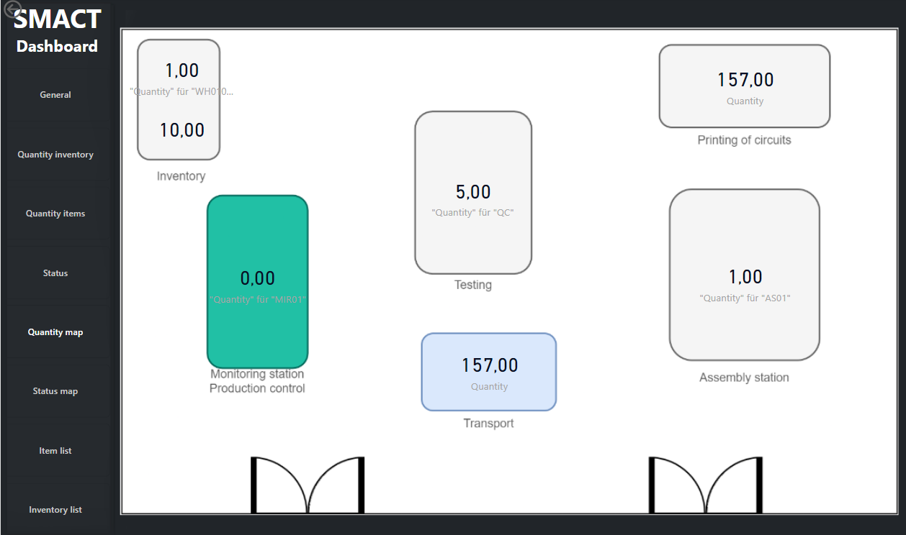

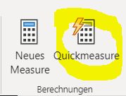 Ein Bild, das Text enthält.

I used the Quickmeasure tool with the filter-option to filter the Quantities of the Inventorys. On the pictures above you can see how I did it. But the diagramm isnt completed yet, because I didn’t have the data to fill in all Inventorys. To get this data I used the following queries:

* select [Bin Code], sum(Quantity) from [CRONUS Smact$Warehouse Entry$437dbf0e-84ff-417a-965d-ed2bb9650972] group by [Bin Code] order by [Bin Code]

On the fifth page, I used the same map as on the fourth page and tried to use an R script and a measure to mark the stations that are currently being used.

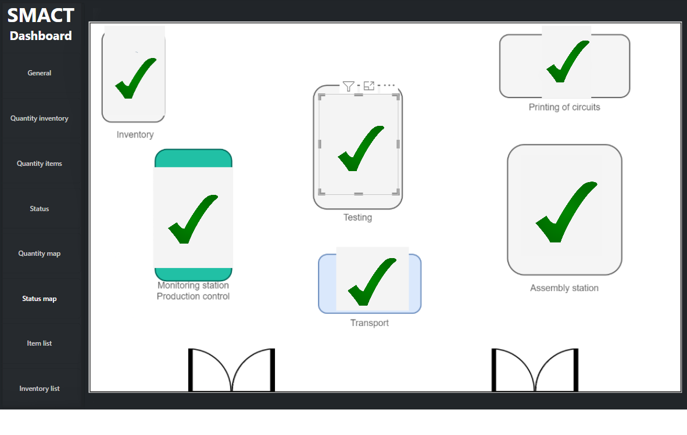

I could not quite finish the chart because I had too little information about the data and data itself.

Here is the measure I used as a condition to see if the clocks controlling the activity are active or not:

Measure = IF(ISEMPTY(VALUES(Watches[Ending Date-Time])) && NOT(ISEMPTY(VALUES(Watches[Starting Date-Time]))), "C:\Users\sirfa\Pictures\Yes.png","C:\Users\sirfa\Pictures\240px-No-Symbol.png")

I then selected this measure and used R-Script as the visualisation method. I then created this R-script which allows me to adjust the images live and change them dynamically.

# *Fügen oder geben Sie hier Ihren Skriptcode ein:´*

#*load libraries*

library(png)

library(grid)

library(ggplot2)

# *get the url string from the imported data frame. Convert it to a character vector.*

urlstring <- as.vector(dataset[1,1])

# *if you use an image URL, you have to download the file first:*

#*z <- tempfile()*

#*download.file(url = urlstring,destfile = z,mode="wb")*

#*read the PNG image file*

pic <- readPNG(urlstring)

# *create a raster of the PNG file*

g<-rasterGrob(pic,interpolate=TRUE)

# *create a plot and add the image*

p <- qplot(1:10,1:10,geom="blank") + annotation_custom(g,xmin=-Inf,xmax=Inf,ymin=-Inf,ymax=Inf)

# *remove all clutter from the plot and display it*

p + theme(axis.line=element_blank(),axis.text.x=element_blank(),

          axis.text.y=element_blank(),axis.ticks=element_blank(),

          axis.title.x=element_blank(),

          axis.title.y=element_blank(),legend.position="none",

          panel.background=element_blank(),panel.border=element_blank(),panel.grid.major=element_blank(),

          panel.grid.minor=element_blank(),plot.background=element_blank())

To get this data I used the following queries:

* select [Ending Date-Time], [Starting Date-Time] from [CRONUS Smact$EOSFH Report Task$59df57a5-0fc9-45d9-858a-950a1e229031] csertdafdaae order by [Ending Date-Time], [Starting Date-Time]

On the last two pages, the abbreviations for the products and warehouses are given so that you can understand what it is all about.

Ein Bild, das Text enthält.
Ein Bild, das Text, Bildschirm, Screenshot enthält.

I then also added the page navigator on the page for more clarity. It updates automatically when you change the name of a page or add a new one.

Ein Bild, das Text enthält.

If you have any further questions about this project, just send me an email.

Email: [mairfabian04@gmail.com](mailto:mairfabian04@gmail.com)